2019-2020 Building Safety Plan
691 St. Nicholas Avenue
Neighborhood Charter School Harlem

District-Wide and Building Level School Safety Plan

Draft Date: July 22, 2019
Table of Contents
INTRODUCTION 3
Key School Data 4
School Chain of Command 4
GENERAL CONSIDERATIONS AND PLANNING GUIDELINES 4
Purpose 4
School Safety Team 5
Concept of Operations 5
RISK REDUCTION/ INTERVENTION STRATEGIES 5
Prevention/Intervention Strategies 5
Training, Drills and Exercises 5
Implementation of School Security 7
Vital Education Agency Information 8
Early Detection of Potentially Violent Behaviors 8
Hazard Identification 8
RESPONSE 8
Notification and Activation (Internal and External Communications) 8
Situational Responses 9
Multi-Hazard Response 9
Summary of Situations and Associated Communication Code Phrases 10
Responses to Implied or Direct Threats of Acts of Violence 10
Response to Acts of Violence 11
Response Protocols 11
Arrangements for Obtaining Emergency Assistance from Local Government 12
Procedures for Obtaining Advice and Assistance from Local Government Officials 12
School (District) Resources Available for Use in an Emergency 12
Procedures to Coordinate the Use of School District Resources and Manpower during Emergencies 12
Protective Action Options 12
Missing student or student who has run away from assigned staff. 13
RECOVERY 15
District Support for Buildings 15
Disaster Mental Health Services 15
APPENDICES 15
Appendix 1: School Buildings covered by District-wide School Safety (SAVE) Plan 15
Appendix 2: Emergency Contact Information 16

General Information

Address Information
Street Address: | 691 St. Nicholas Avenue
City/State/Zip: | New York, NY10030

Building Council
School | Person | Primary Contact Information
Neighborhood Charter Schools | Sherita Smith | Main Phone | 646-701-7117
 |  | Fax Number | 917-725-9023

INTRODUCTION
Emergencies in schools must be addressed in an expeditious and effective manner. Schools are at risk of acts of violence, natural, and manmade disasters. To address these threats, the State of New York has enacted the Safe Schools Against Violence in Education (SAVE) law.
Project SAVE is a comprehensive planning effort that addresses prevention, response and recovery with respect to a variety of emergencies in schools.

Charter schools are considered districts in and of themselves. Therefore, even as just one school with just one building, we are required to have both District and Building Level Project SAVE School Safety Plans. This document is 691 Saint Nicholas combined District-wide and Building-Level Project SAVE School Safety Plans (the “Plan” ).

The Neighborhood Charter School: Harlem supports the SAVE Legislation and engaged in a robust planning process to create a School Safety Plan for the 2019 - 2020 school year. Our plan development process includes meetings with the local police, security, school faculty and staff, and students to request participation in creating the plan, and feedback in reviewing the final plan. All constituencies will have full access for input.

The NCSH Safety Team developed the Safety Plan detailed below.

Our goals in creating and implementing our School SAVE Safety Plan are:
- To create an atmosphere and set of practices that prevent violence or unsafe conditions
- To create/implement a plan that will minimize the effects of serious violent incidents and emergencies
- To have an effective response plan for all predictable safety concern situations
- To produce a document that can be used as the basis for informing and training all school constituencies in regard to keeping our school safe.

Plans will be produced for the following multi-hazard situations:

  - Medical emergency
  - Shooting
  - Bomb threat
  - Building Collapse/Explosion
  - Chemical Spill or Natural/Propane Gas Leak
  - Fire Safety/Fire/Evacuation Drills
  - Shelter-In
  - Lockdown Drills
  - Missing Student Protocol
  - Rapid Dismissal

Building Information

Address Information
Street Address: 691 St. Nicholas Avenue
City/State/Zip: New York, NY 10030

How many floors does the building have that are used for instructional or administrational purposes? | 6
All Public Schools should be prepared to Host other Public School in the event of an emergency requiring relocation. “Common areas” can be used for these purposes. The capacity of the common areas identified in this building are shown below:
Cafeteria(s): 226 TBD PA Permit
Gymnasium(s): 334 TBD PA Permit
Where is the electrical control panel in the building? | Main Panel in Electrical Room in 1st Floor, secondary panels in each floor on IDF rooms, kitchen and gym
Where is the gas/oil shutoff in the building? | There is no gas in the building
Where is the water shutoff in the building? | 1st floor and 3rd floor water meter rooms
Where is the Fire Alarm Control Panel in the building? | NCS Lobby
Does this building have a panic button? | NO
Where is the Panic Button located? | N/A
Does this building have a Classroom Call Switch? | Yes
Where is the remote control panel for electromagnetic locks in the building? | No electromagnetic locks
Does this building have a basement? | No
Does this building have a fully functioning sprinkler system in both classrooms and corridors? | Yes
Does this building have a sub-basement? | No
Where are the chemicals/controlled substances used in the science lab stored? | N/A
Who is responsible for laboratory safety, including storage and maintenance of chemicals and laboratory equipment? | N/A
Does this building have central air conditioning? | Yes
Does this building have ventilation system? | Yes
If yes, what type of ventilation system is it? | Ventilation system brings fresh air through the vents at the sides of the building
If yes, where are the shut-off controls located? | 6th Floor
What is the storage location for hazardous materials that are often used by school custodians (e.g., bleaches; combustible cleaning materials)? | Garbage refuse corridor on 1st floor

*All hazardous materials must be kept in an appropriate area that is locked, isolated and properly ventilated.
Intrusion Alarm System
Does this building have an Intrusion Alarm System? | Yes
Is it in working order? | Yes
Are the exit doors connected to the Intrusion Alarm System? | All exterior doors are connected
Exit Door Alarm System
Does this building have an Exit Door Alarm System? | Yes
How many doors are connected to the Alarm System? | 25
How many DOE Staff members have access to reset the Alarm System? | TBD
CCTV/Video Surveillance System
Does this building have a CCTV/Video Surveillance System? | Yes
How many cameras are installed? | TBD
What kind of device is used to record video images? | CPU
What specific areas are under surveillance? | Main Entrances and Building Perimeter
Who oversees daily operation of the surveillance system? | Security
Main Entrance Monitor
The main entrance must remain unlocked, accessible and monitored by a staff member or Security Guard responsible for the implementation of the Visitor Control Procedures while the school building is open.

Critical Security Notifications and Offices (These will be added in the final draft)

Charter Authorizer Contacts??
Office of Safety & Youth Development (Mark Rampersant, Senior Executive Director) | (212) 639-9675
Emergency Information Center (EIC) | (718) 391-8566
Office of Pupil Transportation | (718) 784-3313
New York City Police Department – 33rd Precinct Contacts
Community Affairs | (212) 927-3891
City and New York State Agencies
Office of Special Commissioner of Investigations for the New York City School District | (212) 510-1400
New York State Central Register (Reporting of Suspected Child Abuse) | (800) 342-3720
311 Government and Information Services Hotline
School Safety Plan Technical Assistance

Neighborhood Charter School
Office | Room No.
A.P. Administration Office (K-4) | 304
A.P. Administration Office (5-8) | 515
A.P. Guidance Office | 102
Cafeteria | 201
Dean's Office (K-4) | 304
Dean's Office (5-8) | 515
Main Office | 100
General Office (Special Education) | 104
General Office (Network) | 105
Gymnasium | 310
Gymnasium Office/Storage | 310A
Nurse's Office | 108
Speech Room | 301
Speech Room | 409
Speech Room | 410
Speech Room | 509
Speech Room | 513
School Psychologist | 401
Principal's Office | 602

Principal (NCS – Michael Renda) | NAME
Phone: 646-701-7117 | Fax: 914-462-3435
Hours of Operation 7:00 AM to 5:30 PM
How many floors of the building does this school/program/academy use? | 6
Staff
Teachers: | #73
Paraprofessionals: | #10
School Aides: | #7
Supervisors/Administrators: | #8
Secretaries: | #3
Additional Staff: | #27 (Curriculum, SpED, SLP)
Other: | #10 (Network, Facilities, IT, Finance)
Total: | #138
# of Students Per Grade Served
# of Grade K | #90
# of Grade 1 | #75
# of Grade 2 | #74
# of Grade 3 | #76
# of Grade 4 | #100
# of Grade 5 | #65
# of Grade 6 | #67
# of Grade 7 | #65
# of Grade 8 | #56
Total for Grades Served | 668

Building Response Teams Building Response Teams – NCS This should be entered closer to school opening
The Building Response Team (BRT) should consist of a BRT Leader and at least five additional staff volunteers who form the building’s core emergency response group. This school’s Building Response Team includes:

Name | Role | Telephone
Michelle Santos | BRT Leader | 646-943-3676
Nadia Brown | Recorder | 646-701-7117
Michael Renda | Assembly Point Coordinator
Jasmine Keitt | After-School Emergency Officer
 | After-School Incident Assessor
Jared Quiza | Recorder
Jenny Buck | BRT Member

School/Program/Academy Information (information to be verified and entered closer to Aug)
Dismissal Schedules and Information – NCS (K-4)

Building Name | Dismissal Time | Door | Staff Assigned | Supervised By
NCSH | 3:30 PM |  | Jared Quiza | Michael Renda

Dismissal Schedules and Information – NCS (5-8)

Building Name | Dismissal Time | Door | Staff Assigned | Supervised By
NCSH | 4:00 PM |  | Jenny Buck | Michael Renda
After School Building Response Team - NCS

Name | Title | Contact Number
Michelle Santos | Director of Operations
Michael Renda | Principal
Jared Quiza | Assistant Principal (K-4)
Jenny Buck | Assistant Principal (5-8)
Jasmine Keitt | After School Coordinator

After School Building Schedule - NCS

Location | Activity | Mon | Tue | Wed | Thu | Fri | Sat
Cafeteria | AFTER SCHOOL PRGM | 3:45 PM | 3:45 PM | 3:45 PM | 3:45 PM | 3:45 PM | N/A
 |  | 5:30 PM | 5:30 PM | 5:30 PM | 5:30 PM | 5:30 PM | N/A
Supervisor: (Jasmine Keitt) |  |  |  | Special Need Students: TBD
Administrative Office: Rm 100 |  |  |  | Relocation Site(s): XXXXXXXXXXXXXX
Scanning: No |  |  |  | Medical supplies are kept at: Nurse’s Office |  | Rm 108

RISK REDUCTION/ INTERVENTION STRATEGIES

Prevention/Intervention Strategies
NCSH strongly believes in the wisdom of implementing violence prevention and intervention protocols as a primary means of ensuring student/school safety. These protocols take the form of Program Initiatives, Training/Drills/Exercises, School Security Policies and Procedures, and Maintenance of Educational Agency contact information as per the below:
NCSH will also create a positive, safe learning environment for students by implementing a community service program and by creating school schedules that minimize potential for conflicts or altercations.

Training, Drills and Exercises
- As part of plan development, the Safety Team will review emergency response plans with security professionals and administrators from other schools to ensure their feasibility and thoroughness.
- The Safety Team will conduct ‘table top’ exercises – playing through the execution of each multi-hazard plan using an actual school and neighborhood layout diagram.
  - The Safety Team is made up of:
    - Principal
    - Assistant Principal
    - Director of Operations
    - Security/Safety Agent
    - School Nurse
- NCSH will review the detail of its Safety Plans with all faculty and staff prior to school opening, ensuring all are clear on all roles and responsibilities as well as logistics. Staff will sign off on having reviewed and understood School Safety Plans.
- NCSH will review all emergency response plans with students within the first 2 weeks of school, to ensure all students understand expectations for their action/behavior and that of the entire school community.
- NCSH will conduct the mandated actual safety (fire and intruder alert) drills as follows: two intruder alert drills, one in December and one in February. These drills will be conducted in coordination with local emergency response and preparedness officials, as follows:
  - The School will schedule the dates and times of drills with local officials.

Implementation of School Security
School Safety/Security roles at NCSH are expected to be as follows:
- School Security – Alex Lewis and Samuel Camacho
During the school day one security officer will be located at the lobby and the other will patrol
halls at regular hours.

Vital Education Agency Information
An updated School Staff contact list (with cell phone numbers) will be maintained by the main office staff and placed within the school’s main offices. This binder will also contain: a list of all local emergency contact names and numbers (police, fire, hospital, Board Members, and local officials), Emergency Contact Information for all school staff, and a sheet with the demographics of the school (number of students, number of staff, organization chart for the school). Next to that binder will be a ‘Student Emergency Contact Binder’ with Emergency Contact sheets for each student.

Hazard Identification
Through a walkthrough and in consultation with local police and School Security staff, as part of developing the School Safety Plan, the School Safety Team identified the following potential emergency sites and situations:

Potential Emergency Site | Related Potential Emergency  Situation | Risk Reduction Plan
School Building – Gym | Student confrontation / Intruder Alert | Have stairwells and other isolated areas monitored during  transitions.
Cafeteria | Student confrontation | Always have 2-5 staff within cafeteria while  students are there.
Bus Release Time | Student confrontation / Intruder / lost child | Ensure enough staff are monitoring children that use  busing.

RESPONSE

Notification and Activation (Internal and External Communications)
Upon the occurrence of violent incident, building leadership will contact the appropriate local law enforcement officials. A list of local law enforcement officials and contact information will be maintained in the School “Emergency/Safety’ Binder in the Main Office.
In the event of disaster or violent act, as necessary the Leadership will also notify all staff via all call page if immediate communication is required, or via conducting an emergency staff meeting if the situation does not require immediate communication.
As necessary, the School will notify parents of a violent incident or early dismissal through use of the One Call System and/or email and/or an Advisory phone chain (faculty member calls all parents within their Advisory). Parent contact information will be maintained on Student Emergency Contact forms, and with a school-wide email group.

Note – Families will be instructed in the Family/Student Handbook as to where to find update information and contact numbers for the school in the event of any emergency situation.

Situational Responses

Multi-Hazard Response

Emergency Situation | Response
Fire | - Sound fire alarm  - Teacher escort current class to agreed meeting location. Students stay with teachers.  - Site Coordinator, Academic Dean, and Operations Associate take their cell phones  - Site Coordinator, Academic Dean, and Operations Associate  – Pick up Emergency Bag (with student emergency contact binder, school safety plan, staff sign sheet, sign to hold up to indicate their location)  - ‘Sweep’ staff ensure building is empty  - Meet at designated spot  - Site Coordinator confirm all clear  - Return to school
Intruder in Building | - Over intercom, Operations Associate announce there is an intruder in the building with code word “Mr. Wallbounds is in the building”.  - All students in hallways are taken to the nearest classroom by school personnel  - Teachers lock classroom doors and move students away from windows.  - Site Coordinator and assigned individuals conduct a building sweep to locate intruder.  - The Site Coordinator and School Safety Agent contact local police, and others as required.  - If the intruder is found and the situation is stable, or no intruder is found within the building, an “All Clear announcement of (Mr. Wallbounds left the building) will be made over the intercom system  - In the event the intercom system is not working, the Academic Dean or designated individuals will go from room  to room with the all clear message.

Summary of Situations and Associated Communication Code Phrases
Emergency Situation | Communication Code Phrases
Intruder – Is In the Building | Mr. Wallbounds is in the building.
Intruder – Alert Is Over | Mr. Wallbounds left the building

School (District) Resources Available for Use in an Emergency
The following school (aka in this instance, ‘District’) resources are available in case of an emergency are:

- Cell Phones
- Tool Box
- First Aid Kit
- Flashlight
- Moving Carts
- Laptops
- One Call Now messaging system

Procedures to Coordinate the Use of School District Resources and Manpower during Emergencies
(see Multi-Hazard Plans)

Protective Action Options
Situation | Plan
School Cancellation | - Monitor situation that may warrant school cancellation (Principal)  - Make cancellation determination  - Inform Families/Students  - Inform Staff  - Inform Board  - As necessary, inform other parties (e.g. shared building)
Early Dismissal | - Monitor situation that may warrant early dismissal (Principal)  - Make early dismissal determination  - Agree time to send early dismissal signal (intercom)  - Contact Transportation providers and make required arrangements  - Inform Families/Students  - Inform Staff  - Retain appropriate school personnel on site until all  students have been returned home/picked up
Evacuation (before, during and after school hours) | - Determine level of threat  - Contact Transportation providers and provisionally make required arrangements  - Clear all evacuation routes and sites  - Evacuate staff and students to pre-arranged evacuation  site
- Account for all students and staff populations. Report any missing persons to the Site Director
- Make determination regarding early dismissal
- If dismiss early, contact families/transportation providers for pick up
- Ensure adult/continued school supervision/security
- Retain appropriate school personnel on site until all
students have been returned home/picked up
Movement to Sheltering Sites | - Determine level of threat  - Confirm sheltering location, depending on nature of incident  - Evacuate staff and students to pre-arranged sheltering site  - Account for all students and staff populations. Report any missing persons to Academic Dean  - Make determination regarding early dismissal  - If dismiss early, contact families/transportation providers for pick up  - Ensure adult/continued school supervision/security  - Retain appropriate school personnel on site until all  students have been returned home/picked up

RECOVERY

Disaster Mental Health Services
Disaster Mental Health Resources will be coordinated directly by NCSH (acting as District) in support of Post-Incident Response Teams.
After the recovery stage of any incident, the NCSH School Safety Team will conduct an internal Post Mortem that will include re-evaluations of violence prevention and school safety activities as appropriate to improve our plan. Updates to the Safety Plan will be made as appropriate.

Emergency Assignments, Egresses and Relocation Sites
Emergency Egresses
Every room occupied by students and/or staff, including those used intermittently throughout the day, must have a primary and alternate route to exit the room and, ultimately, the building.

When school principals and/or the Incident Commander (from NYPD, FDNY, OEM, DOHMH, or another designated external agency overseeing management of the emergency) have made the decision to evacuate a school building, students, staff, and visitors to the building must exit using the designated egress and/or alternate egress route.

Please note: exits and streets are both required in this section. Cafeteria / Lunchroom, Auditorium, and Gymnasium, where appropriate, should be included in the list of rooms and exits.

First Floor

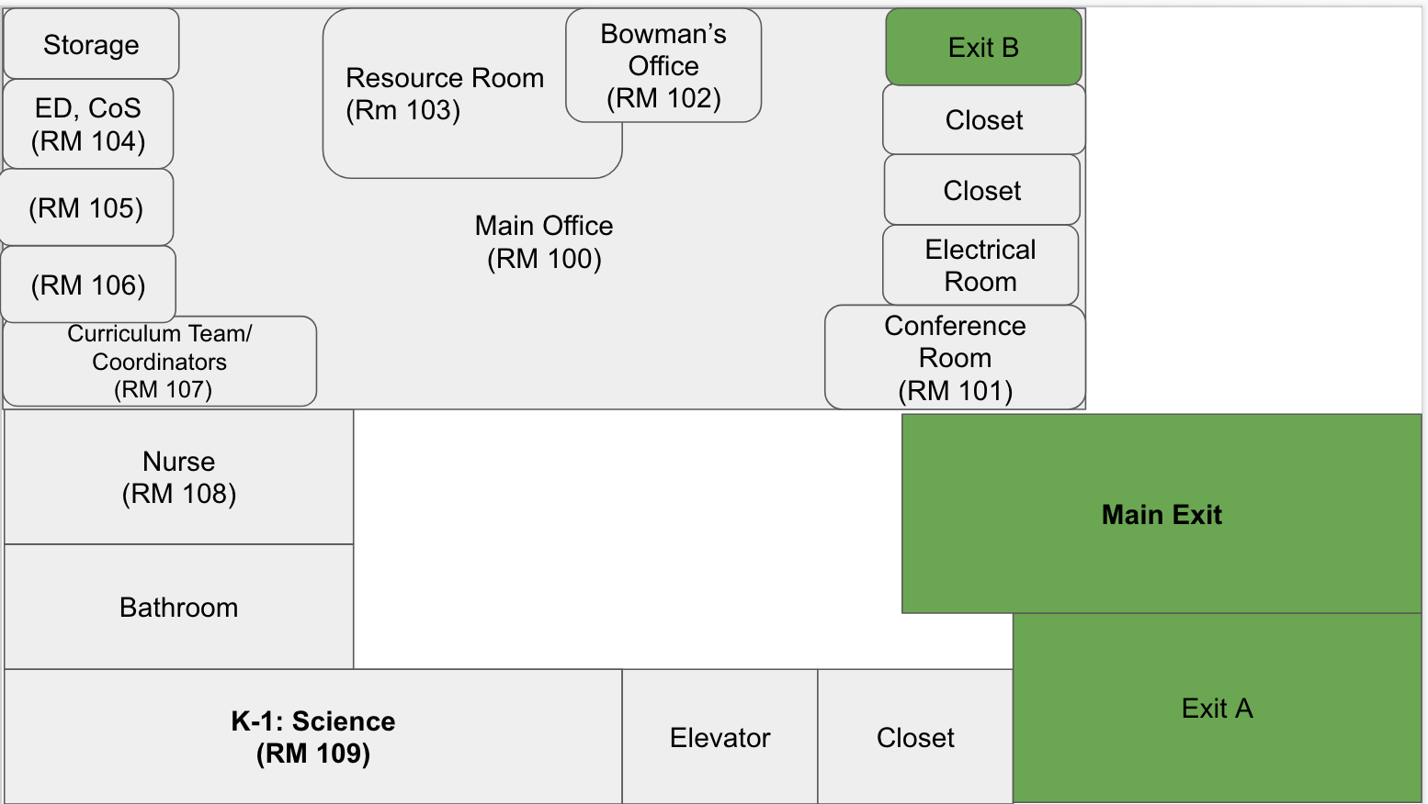
Second Floor

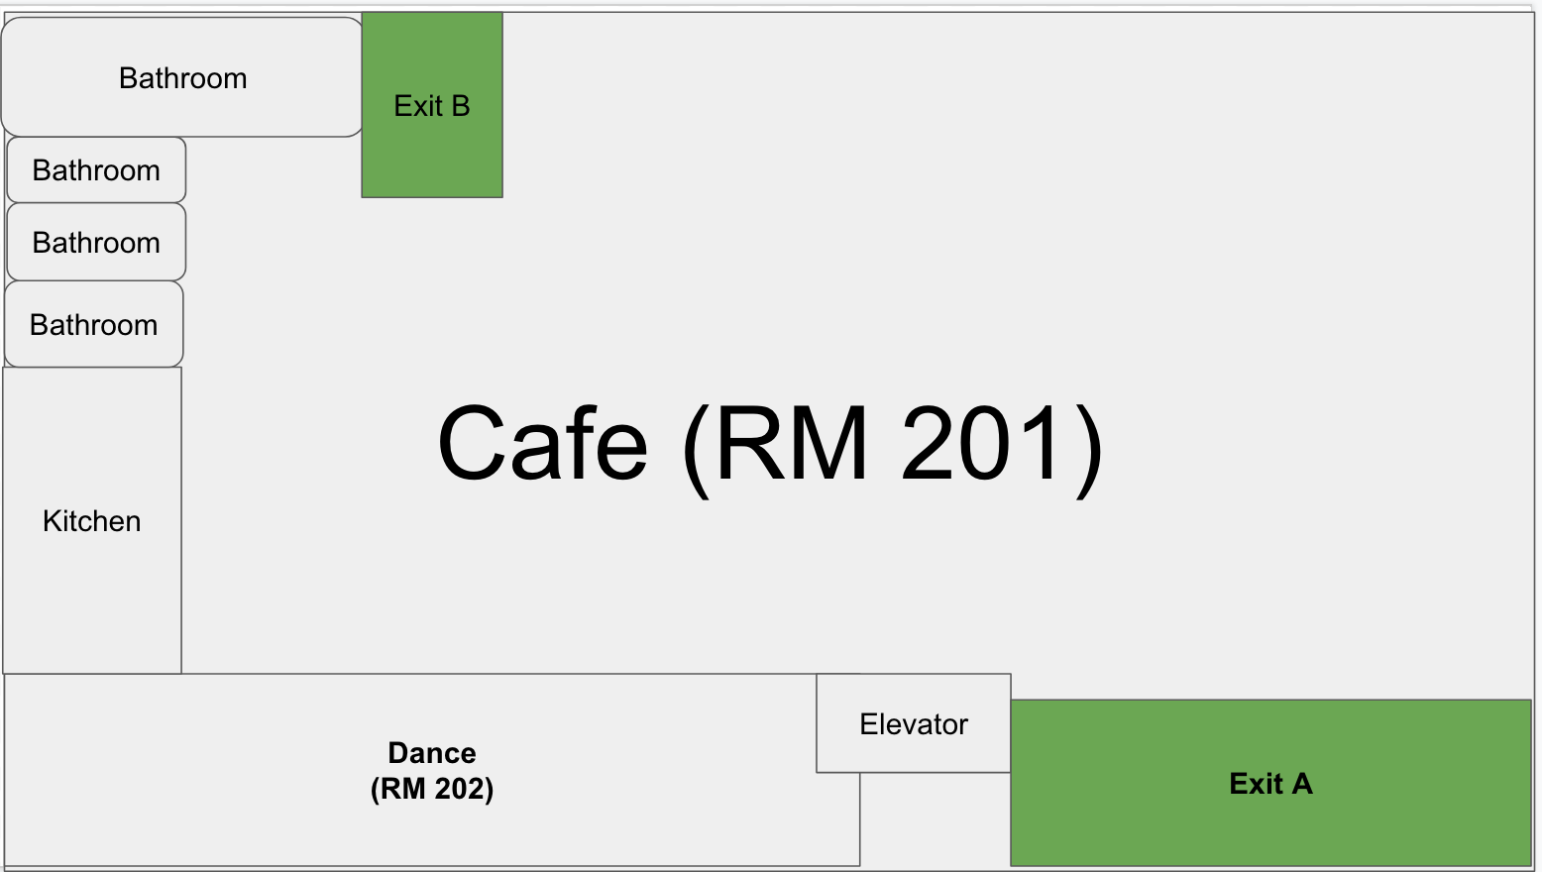

Third Floor

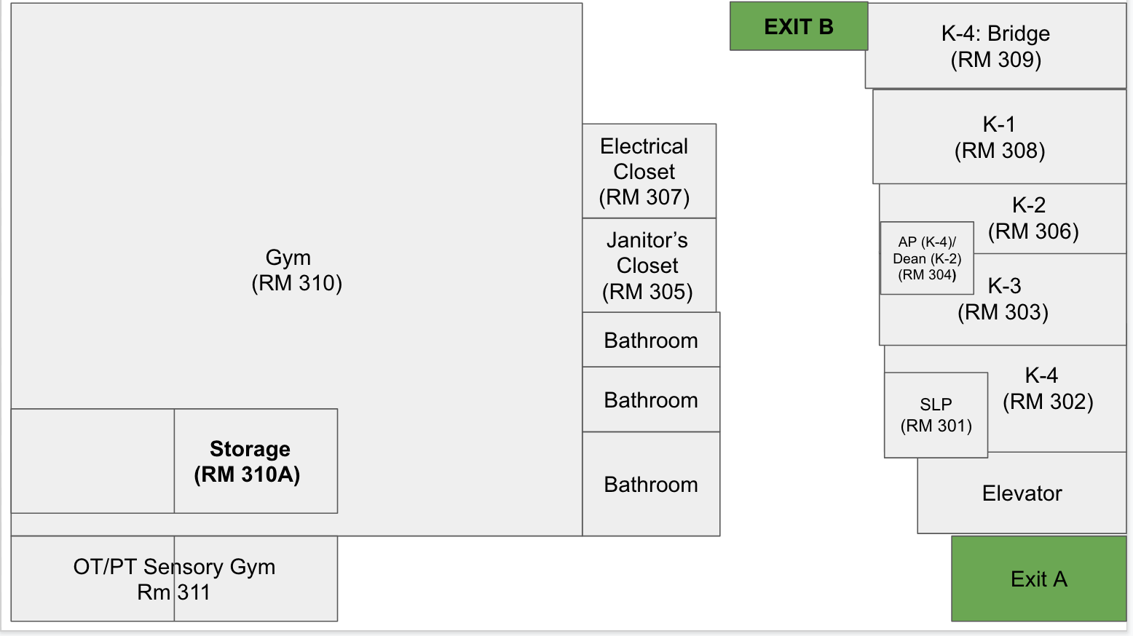

Fourth Floor

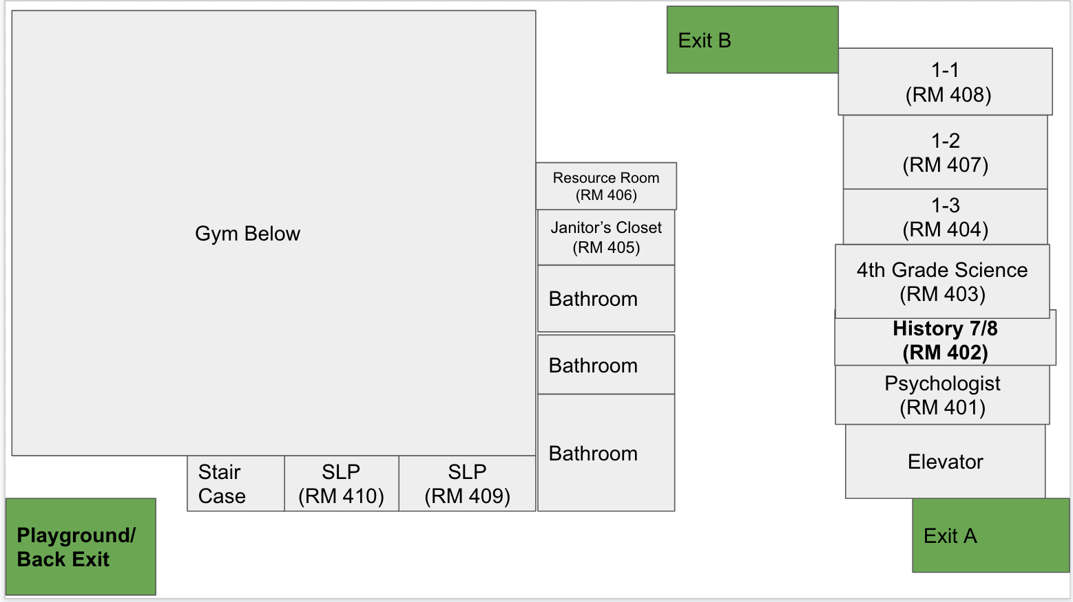

Fifth Floor

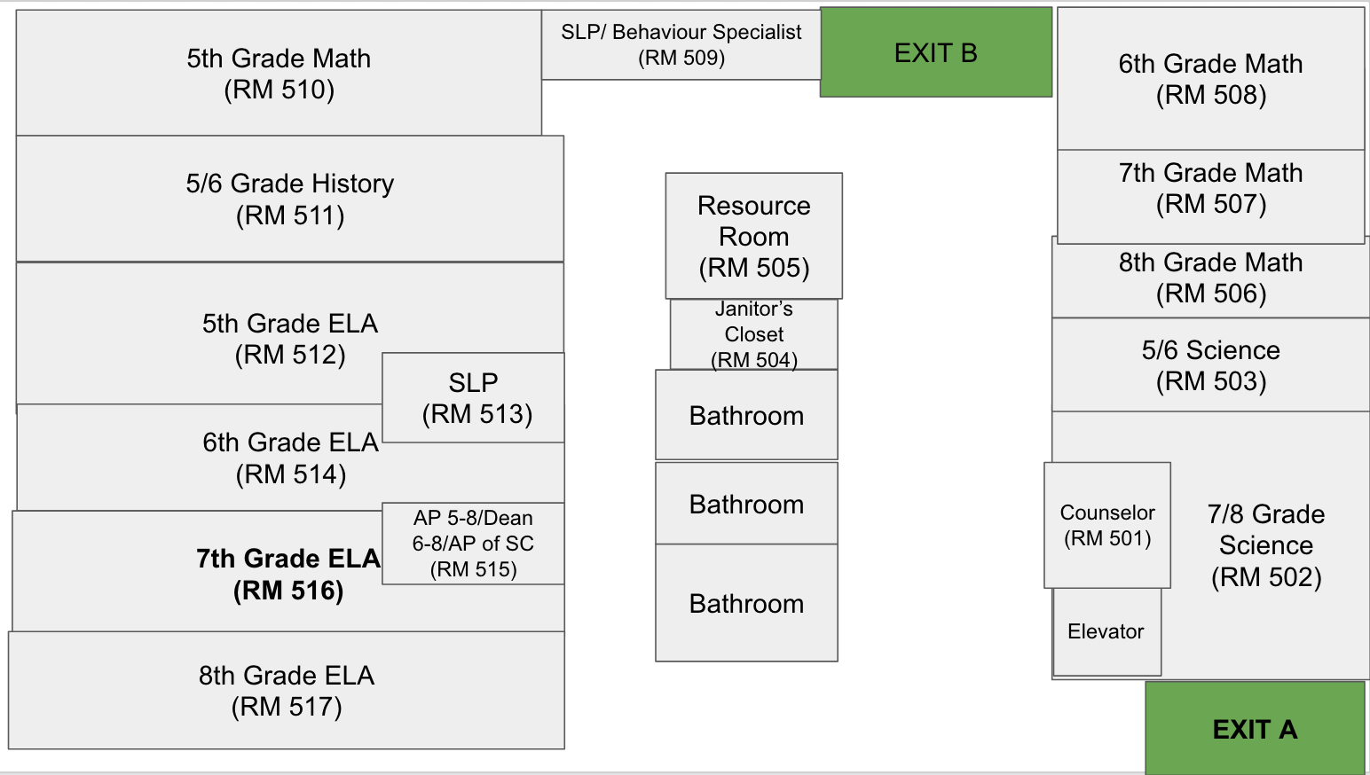

Sixth Floor

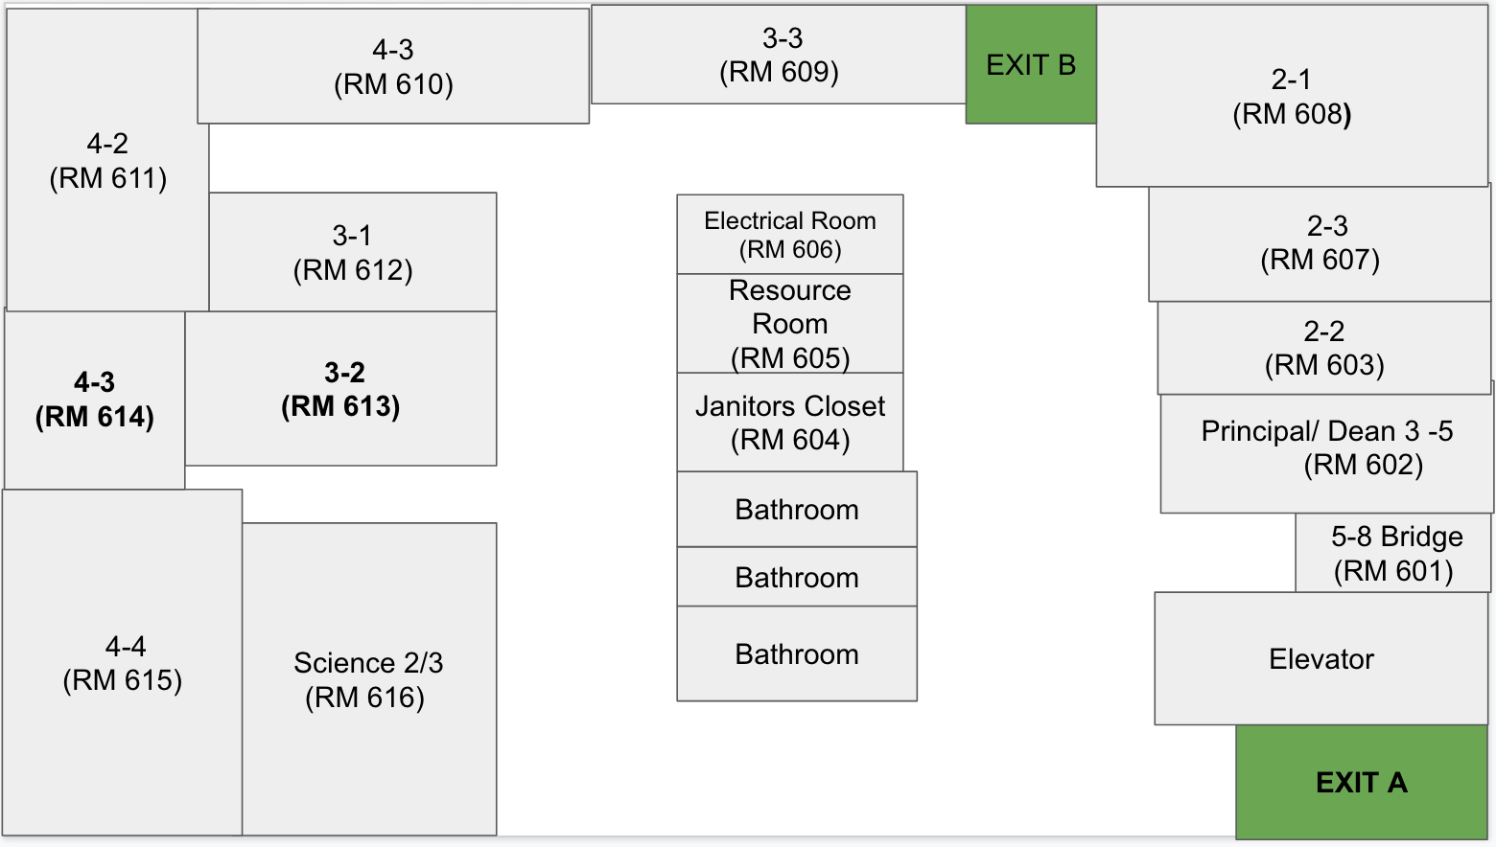
Relocation Sites
Short-term relocation sites should provide shelter to students and staff and allow for easy communication with Borough Safety Directors and other external supports. Short-term Relocation Sites should be able to serve the instructional and educational needs of the relocating school for approximately one week.

The principal or designee as identified in the safety plan “chain of command” is responsible for all students and staff at the relocation site. The principal or designee as identified in the safety plan “chain of command” is responsible for all students and staff at the relocation site.

The primary and secondary relocation sites should be in close proximity to the main school site. In an emergency that affects the school’s entire neighborhood or a larger area, the primary and secondary location may be rendered unusable. In such cases, the third, “out of area” location should be used.

In situations where relocations may extend past one week (known as long term relocation) the [School leader/authorizer] will determine an appropriate relocation site that may not be listed in the safety plan to accommodate the needs of multiple schools. As a result, this may also occur when an emergency requires the simultaneous relocation of multiple schools that have identified the same relocation site. Principals will be informed of the long-term relocation site.

NCS

Destination | Relocation site | Designee at Relocation Site | Capacity | Accessibility | Grades | # of People
Primary | HSA | Eric Pryor
Secondary | Mt Zion Lutheran Church | Lula Urquhart
Out of Area | TBD

Shelter-In

Designate school staff members who will be responsible for reporting to specific building exit doors during a Shelter- In.

During a Shelter-In all exit doors including kitchen doors and loading docks must be secured to prevent entry/egress during a Shelter-In emergency.

Principals should not be assigned to exit doors. A School Security Guard can be assigned to exit doors.

Shelter-In vs. Lockdown

The differentiation between Shelter-In and Lockdown is a critical element in GRP. A Shelter-In recovers all students from outside the building, secures the building perimeter and locks all outside doors. This would be implemented when there is a threat or hazard outside of the building. Criminal activity, dangerous events in the community, or even a vicious dog on the sidewalk would be examples of a Shelter-In response. While the Shelter-In response encourages greater staff situational awareness, it allows for educational practices to continue with little classroom interruption or distraction. Lockdown is a classroom-based protocol that requires locking the classroom door, turning off the lights and placing students out of sight of any corridor windows. Student action during Lockdown is to remain quiet.

Emergency Communications/Command Post
For emergency situations where the Building Response Team (BRT) is activated, a command post must be established. This includes times when a building/school may need to Lockdown, Shelter-in, or Evacuate. The command center is the single location where all principals will report to gather and disseminate information to the members of the Building Response Team. The BRT Leader will obtain updates from activated BRT members and provide information to all principals so that a single decision can be made to ensure the safety of all staff and students.

All buildings will identify a Primary (internal) location as well as an Alternate (internal) location to be used as a command center.

These locations should have specific equipment and materials readily available. This includes; floor plans; bullhorns; radios; batteries and chargers; and working telephones. In cases where an evacuation is necessary the command center will need to be established outside the perimeter of the school site, in close proximity to the building at a location that will not interfere with first responders performing emergency operations. The external command center should be located in a location that can allow for schools to communicate with first responders.

Reminder: During Bomb Treats or incidents of suspicious packages, electronic communications (Cell phones, 2-way radios) is prohibited until authorized by first responders.

The Command Center locations are identified below.

Command Post | Description
Primary: Main Office | Rm # 100
Alternate: Gymnasium | Rm # 201
External Command Post Location: | St. Nicholas Park

Medical Emergency Response Information
Health Protocols

Health information should be reviewed by a nurse, administrative staff, or other trained staff, in consultation with medical professionals. The person at your school (may be same as above) who is responsible for reviewing information about health conditions and consulting with medical professionals, as appropriate, is:

School | Name | Title
NCSH | Michelle Santos | Director of Operations

AED (Automated External Defibrillator) Procedures

According to New York State Education Law Section 917, all public schools must provide and maintain AED equipment at strategic locations to ensure access for use during medical emergencies. Whenever public-school facilities are used for school-sponsored or school-approved curricular or extracurricular events or activities and whenever a school- sponsored athletic contest is held at any location, school officials and administrators must ensure the presence of at least one AED/CPR certified staff volunteer. Where a school-sponsored competitive athletic event is held at a site other than a public school facility, school officials shall assure that AED equipment is provided on-site.

Public school facilities are deemed “public access defibrillation (PAD) sites” and are subject to the requirements and limitations of this definition. Schools are required to post a list of the locations of each AED unit at their main entrance. Ensure your AED location poster is posted at the school’s main entrance and is easily visible. You may print your AED location poster from the Department of Education’s AED vendor Emergency Skills, Inc.’s (ESI) web site http://doe.emergencyskills.com/mainpage.php.
Please note you will need to be logged in to your school’s profile to do this as each AED poster is customized per school.

AED Locations and Status

Serial Number | Building | Location | Status
B-XXXX | NCSH | Lobby | A
B-XXX | NCSH | 3rd Floor | A

- Training

  - Each school building should ensure that at least 2 school personnel are trained. Schools that share a building are required to maintain adequate AED/CPR certified staff volunteers.

  - All coaches of intramural sports must maintain the required AED/CPR certification at all times.

Training certification must include successful performance of use of the AED, CPR for adults, children, and infants, and choking procedures for adults, children, and infants. Training provided by ESI is the best way to ensure staff has received appropriate training. In addition to the training provided by ESI, the DOE currently accepts certifications approved by the American Heart Association (AHA) and the American Safety and Health Institute (ASHI). Please note that if training is obtained from an agency other than ESI, reimbursement of any associated costs is not available as our contracted vendor provides the training free of charge to all staff.

Name | School | Building Name | Status | AED | CPR
Michelle Santos | NCSH | 691 Saint Nicholas Ave | Active
Juana Calderon | NCSH |  | Active
Alison Rosnick | NCSH |  | Active
Michael Renda | NCSH |  | Active
Sean Edwards | NCSH |  | Active
Nadia Brown | NCSH |  | Pending
Derrica Newman | NCSH |  | Pending

- Contact Person

  - Each principal must designate an AED contact person to coordinate all AED activities at the school.

  - The AED contact must have a work email address that he or she checks daily and responds to. Do not designate a person without access to a computer at work, or with a personal email address (e.g. AOL, hotmail, or yahoo).

NCS
Designated AED Contact Person | Position | Telephone | Fax
Michelle Santos | Primary | 646-701-7117 | 914-462-3435
Jared Quiza | Alternate | 646-701-7117 | 914-462-3435

- Drills

- Each school has an AED Site Response Plan, as generated in the school safety plan, indicating the steps to be performed during an actual medical emergency.

- Every school must issue a copy of the AED Site Response Plan to all employees, and must post it prominently in the school.

- Twice a year, representatives of ESI will make unannounced visits to the schools to perform mock drills of the AED Site Response Plan. Schools may not receive advanced warning of these visits, and cannot re-schedule them. Schools are expected to participate in the drill as it is the best way to ensure they are ready to respond in the event of an actual emergency which can occur at any time,

- Each school will be evaluated on its emergency readiness during each drill.

School | Primary Procedure | Alternate Procedure
NCSH | PA System | Email

In the event that there is a power outage, the following procedure will be followed:

[School administration will use walkie talkies to communicate]

- Incidents

Immediately report any incident requiring the use of an AED to the Office of School Health at (718) 391-8227 and ESI at (212) 564-6833. It is imperative that incidents be reported to OSH in a timely manner as data from the AED unit utilized must be retrieved and an incident report is required to be filed within 5 business days of the incident.

- AED Contact Information

Name | Sherry Fusco
Title | Senior Project Manager
Telephone | 212-564-6833
Email Address | Sherry@emergencyskills.com

Emergency Situations, Procedures and School Community Notifications

The key to handling a crisis, disaster or emergency at the school level is to have plans and protocols in place that are regularly practiced by administrators, staff and students.

This section outlines protocols intended to guide administrators and staff in maintaining calm and order during an emergency. The identified examples reflect the types of events that can or may occur in schools. This list is not intended to be exhaustive.

Notifications to the School Community
After a serious incident has occurred (especially any time a General Response Protocol action has been taken), school officials may need to consider notifying families of what occurred. Notifications must be approved by your legal counsel and executive director before sending to families.

911 Protocols

Can 911 be dialed from any phone in the building(s) included on this plan? No
Dialing prefix: N/A

Shooting (OUTSIDE OF THE SCHOOL)

Please note: Schools may decide to, or be directed to Shelter-In or conduct an Evacuation. They must be prepared for both scenarios.
NOTIFY Principal/designee, Borough Safety Director and the School Security Guard or Supervisor.
Follow the GRP protocol for Shelter-In, as outlined in previous section.
CONTACT:
- 911 – Be prepared to provide:
  - Your NAME and TELEPHONE NUMBER
  - ADDRESS of the school/facility
  - DESCRIPTION of the situation (including number of people involved) and location
  - DESCRIPTION of the shooter / hostage taker
  - TYPE of weapon, if any
  - ENTRANCE for first responders to use, if possible
- Emergency Information Center / Communications Control Center, 718-935-3210
- BRT Leader (who should activate the BRT)
Decision to Shelter-In should be made by Principals/BRT Leader in consultation with SSD.
Note: in some cases the Shelter-In may require the assigned BRT members to report to their assigned exit doors. The Incident Assessor should report to all posts and ensure that BRT members have the required equipment.
Floor Wardens should be deployed to each floor to assist in the Shelter-In, and assist in assessing conditions throughout the building to determine in an internal relocation of some classes is required.
If determined in conjunction with first responders, Evacuate the premises following routes outlined in [Section 7, Emergency Assignments, Egresses, and Relocation Sites].
If the building cannot be re-entered, evacuated students and staff with attendance information are to be sent to the Evacuation Location as identified in [Section 7, Emergency Assignments, Egresses, and Relocation Sites].
Office of Pupil Transportation must be notified for those children who take the bus home.
The BRT Leader should work with first responders to identify the location, number and extent of injured persons. If the victim is part of the school community (staff or student), retrieve the victims’ information with home contact numbers and make notifications as necessary.
School Security Guard / Principal will provide respective Supervisors and arriving agencies with vital information.
For those children who are picked up from school, the parents/guardians need to be advised of the situation and staff should remain at the evacuated school to direct the parents/guardians to the Evacuation Location for pickup.

Bomb Threat

Please note: Schools may decide to, or be directed to Evacuate or conduct a Soft Lockdown. They must be prepared for both scenarios.

IF YOU OBSERVE A SUSPICIOUS PACKAGE, DO NOT TOUCH IT. ALL BOMB THREATS
All communications by LAND LINE or IN PERSON ONLY (No radio or cell phone transmissions).
- CALL 911 and EIC, (718) 935-3210.
- Provide the following information: Your NAME and TELEPHONE NUMBER, ADDRESS of the school/facility, DESCRIPTION of the threat, and LOCATION of bomb inside the building (if known).
- Follow instructions provided by 911 operator.
- TURN off all RADIOS, WIRELESS DEVICES, CELL PHONES, BLACKBERRIES, etc. Such devices MAY cause a bomb to detonate.
BOMB THREAT BY PHONE
- CHECK caller ID to see if there is a number and note down.
- KEEP the caller ON THE LINE as long as possible (Do not hang up on the caller).
- LISTEN CAREFULLY, be polite and SHOW INTEREST.
- Try to KEEP the caller talking so that you can gather more information.
- ASK the following questions:
  - WHEN is the bomb going to explode?
  - WHERE is the bomb right now?
  - WHAT does the bomb LOOK like?
  - What KIND of bomb is it?
  - WHERE are you CALLING FROM?
  - WHY did you place the bomb?

- STAY ATTENTIVE to the following:
  - BACKGROUND sounds and other identifying information on caller’s location
  - Voice Characteristics & Speech Patterns
- Try to WRITE DOWN or record the conversation. (Use BOMB THREAT CHECKLIST on next page.)
- Write down the exact TIME the call was received and the LENGTH of the call.
- Dial *69 (return call) or *57 (caller ID).

BOMB THREAT BY LETTER, E-MAIL, VOICEMAIL, FAX, GRAFFITI
- PRESERVE threat evidence; do NOT delete or erase.
- Do NOT handle the item and isolate if possible.
- MAINTAIN crime scene. Do not clean anything around the area.

NOTIFY
- IN PERSON or on a LAND LINE ONLY, notify Principal or BRT Leader and School Security Guard or Supervisor, and EIC (No radio or cell phone transmissions). ALERT them to the situation and the phone call that was made to 911, and PROVIDE a description of the threat.
- If evacuation is necessary follow GRP Protocols for evacuation and the procedures as shown in [Section 7, Emergency Assignments, Egresses, and Relocation Sites], and assist as necessary.
- In cases where a reported/suspected explosive device is found, the ranking NYPD member at the scene is in command. S/he will consult with ranking Fire Officer and other City Officials, if present, to determine if further evacuation is required or if emergency action taken should be expanded or curtailed.
- If evacuation is not necessary, initiate the procedures for a Soft Lockdown and assist first responders with a search of the building, if requested. No one is to re-enter the building/affected area without authorization from appropriate agency.
- If building cannot be re-entered, Transportation Operator must be notified for those children who take the bus home. For those children who are picked up from school, parents/guardians need to be called and advised of the situation; staff should remain at the evacuated school to direct the parents/guardians to the Evacuation Location for pickup.

FOLLOW UP

- VERIFY that the Principal notified the EIC.
- OBTAIN written statements from all witnesses and deliver to Principal only if approval is given by NYPD Incident Commander.
- ENSURE that the Bomb Threat Checklist from SSP is filled out.

Fire/Evacuation Emergency

CONTACT
- 911
- Principal (notifies the Borough Safety Director)
- Emergency Information Center, (718) 935-3210
- BRT Leader (activates the Building Response Team)
- Custodial Engineer

PULL FIRE ALARM
ASSESS
- Stay AWARE and ALERT.
NOTIFY
- NOTIFY Principal or BRT Leader, and Custodial Engineer of the LOCATION and EXTENT of the emergency situation.
ACTIONS TO TAKE
- ASSESS safety of egress routes.
- If primary egress contains smoke, do not use.
- Feel door with back of hand and if hot, do NOT open.
- Follow GRP for Evacuation and the procedures as defined in [Section 7, Emergency Assignments, Egresses, and Relocation Sites]. An alarm must be sounded and all students and staff must be evacuated when an emergency arises or is suspected. The decision must be made immediately; investigation of the emergency should be made after everyone has safely left the building.
- Close fire doors and other doors to contain fire.
- Direct people to evacuate away from fire and smoke.
- The Principal or BRT Leader should assign a BRT member to join a custodial staff member to direct first responders to the scene.

- Prepare for EARLY DISMISSAL or TRANSPORTATION OF STUDENTS, if necessary. The decision to evacuate will be made only by Principal/BRT Leader in consultation with NYPD SSD. No one is to re-enter the building without authorization from appropriate agency.
- If the building cannot be re-entered, evacuated students and staff with attendance information are to be sent to the Evacuation Location as identified in [Section 7, Emergency Assignments, Egresses, and Relocation Sites]. In addition, the Office of Pupil Transportation must be notified for those children who take the bus home. For those children who are picked up from school, the parents/guardians need to be called and advised of the situation and staff should remain at the evacuated school to direct the parents/guardians to the Evacuation Location for pickup.
FOLLOW-UP
- CONFIRM that the Principal has updated the Emergency Information Center.
- When fire is extinguished, recharge all used fire extinguishers immediately.

Fire Safety & Fire/Evacuation Drills

All school staff should receive an annual orientation session concerning fire safety at the beginning of each year. By the end of this session, participants should:
- Know appropriate methods of transmitting an alarm, including telephones, fire alarm boxes in the school building, and street fire alarm boxes. (Pull-lever stations for the interior alarms are at various locations in the school building, generally near stairs or exits; these interior alarms do not transmit a signal to the Fire Department.);
- Know the location and proper use of fire alarm signal boxes, fire extinguishers, and other fire-fighting apparatus;
- Understand regulations regarding flammable materials, stage settings, decorations, electrical equipment, chemical substances in laboratories, and other potential fire hazards; and,
- Know fire exit drills and evacuation plans.
Fire/Evacuation Drills
Frequent unannounced drills, implemented with proper leadership and discipline, help ensure safe evacuation in an actual emergency. Drills should be planned in advance, and fire safety/evacuation information should be posted conspicuously throughout the building.
- Purpose
- The purpose of fire/evacuation drills is to instruct and train students and staff in emergency evacuation procedures so that they might leave the school building in the shortest time possible and without panic in the event of an actual emergency. On hearing the fire signal (three gongs, four times), pupils (under the leadership of teachers and other school staff) must go to the street without delay.
- Frequency and Monitoring
- AS REQUIRED BY STATE LAW, THE PRINCIPAL SHALL HOLD EMERGENCY DRILLS NO LESS THAN TWELVE TIMES IN EACH SCHOOL YEAR, EIGHT OF WHICH SHALL BE HELD PRIOR TO DECEMBER 31. OF THE REQUIRED TWELVE EMERGENCY DRILLS THAT MUST BE CONDUCTED, FOUR DRILLS MUST BE LOCKDOWN DRILLS AND THE REMAIING EIGHT MUST BE EVACUATION DRILLS. Neglect by a Principal, or other person in charge, to comply with the above requirements is a misdemeanor punishable by a fine and/or imprisonment.
- In buildings with fire escapes, at least four of the drills shall include the use of such escapes.
- In buildings in which summer school is conducted, at least two additional fire/evacuation drills shall be conducted, one of which shall be held the first week of summer school.
- A record and evaluation of each fire/evacuation drill shall be maintained. All drill reports completed by Principals are to be entered in the DOE online Fire/Evacuation Drill data entry page within 48 hours of the commencement of the drill.
- Guidelines
- All students and staff in the school must obey fire drill signals and regulations.
- Equal emphasis should be placed on evacuating the school in a quick and orderly fashion. No running or horseplay shall be tolerated.
- Fire/Evacuation drills shall be conducted under varying circumstances at varying hours and at unannounced times to simulate actual emergency conditions. (For example, one exit should be blocked by closing off the exit area during the fire drill.)
- Ringing the fire bell is the usual signal for a drill. However, staff and students should be aware of alternate procedures in case of malfunctioning of the bell system. Alternate signals, such as classroom bells, public address announcements, hand bells or messengers, may be used.
- Instructions involving fire/evacuation drills and evacuation paths to be used shall be posted in every classroom, auditorium, and cafeteria. (Note: Fire/Evacuation Drill Posters may be ordered in packages of twenty-five from the Division of Contracts and Purchasing online catalog four times per year -- choose item #11252590007 on the FAMIS portal.)
- Details of the school's fire drill/evacuation plan should include the current number of students in holding rooms. Holding rooms are designated areas where physically handicapped students and staff wait for the Fire Department. The Fire Department will provide means of egress, when necessary. The fire drill is not complete until all students are out of the building or in holding rooms. Holding rooms must be left unlocked during occupancy.
- Teachers shall bring attendance information with them to ensure the safe evacuation of all students.

Missing Student Protocol and Responding to Door Alarms

In order to ensure a safe learning environment, it is important that all staff members are familiar with the Missing Student Protocol and the Response to Door Alarms Document which provide guidance on the steps that must be taken when a student is reported lost or missing, and when a door alarm is activated Both documents describe when it is appropriate to activate these protocols. In addition, the elementary school staff should be familiar with the protocol that must followed when an elementary school student is observed leaving the school building or school grounds without authorization.

Using the Missing Student Protocol

This protocol must immediately be followed when a student has been reported missing, the student’s whereabouts cannot be confirmed, and there is concern for the student’s safety or well-being. Schools must be prepared to initiate a soft-lockdown AND assign staff to secure the exit doors in an effort to prevent the student from leaving the building.

The Missing Student Protocol is not always an appropriate response and therefore should not be activated for every situation where a child leaves class or a school building without authorization (i.e. cutting), as the DOE has existing procedures to address these situations. Regardless of whether the protocol is activated, parents must be informed whenever a student leaves a school building without authorization.

In determining whether to activate the protocol, the following shall apply:

The protocol must be activated if the whereabouts of the following students cannot be immediately confirmed:

- All students in Grades K-5

- Any student who has a known physical or emotional condition, or a cognitive disability which interferes with his or her ability to travel independently and interact with the community

In all other situations, schools must consider a number of relevant factors in determining whether the situation requires the activation of the protocol, including:

- Whether the student has a prior history of leaving the building

- Whether the student is dealing with a crisis/trauma or is otherwise vulnerable

- Whether the student’s parent has informed the school of a prior commitment or appointment that requires the student to leave early

- Whether the age and/or maturity of the student is a cause for concern regarding the student’s well-being.
THE FOLLOWING STEPS MUST BE TAKEN IF IT IS DETERMINED THAT THE MISSING STUDENT PROTOCOL SHOULD BE ACTIVATED
If it is confirmed that the student has exited the building:

Immediately call 911 (including transit police), and notify the Principal/Designee, Emergency Information Center (EIC), and the Borough Safety Director (BSD). Provide a clear description of the student, to include the information below:

- Height and approximate weight

- Ethnicity

- Complexion and hair color

- Attire and any distinguishing features

- Verbal or non-verbal

- Languages spoken

In addition, it should also be noted where the child was last observed.

Notify the School Security Guard in the building

Immediately monitor the video surveillance system (if applicable) including perimeter cameras.

Notify the parent.

Review the Blue Card to identify any relatives listed who may live near the school. This information may be
relevant in locating the missing student

Activate the Building Response Team (BRT) and open the Command Post and gather all relevant information necessary to work with first responders and law enforcement (description of the student, blue card information, photograph (if available). If applicable, review the student’s Individual Education Plan (IEP) to determine what additional supports are required.

When the parent arrives at the school, escort the parent to the Command Post so that the parent may discuss the incident with school officials and law enforcement. Where applicable, have the parent coordinator accompany the parent in order to provide additional support to the family. A representative of the school crisis team should also report to the Command Post to provide support to the family.

If it cannot be confirmed that the student has exited the building:
Notify the Principal/Designee and the School Security Guard.

Provide a clear description of the student, including where the child was last observed. Include the information below in the description:

- Height and approximate weight

- Ethnicity

- Complexion and hair color

- Attire and any distinguishing features

- Verbal or non-verbal

- Languages spoken

Activate the BRT, and open the Command Post. Provide all BRT members, School Security Guards, Shelter- In staff, and floor searchers, a description of the student, and if available, a photograph of the student. If applicable, review the student’s IEP to determine what additional supports are required.

Immediately monitor the video surveillance system (if applicable) including perimeter cameras. Immediately monitor the video surveillance system (if applicable) including perimeter cameras.
If the student is observed on the camera system, immediately deploy search staff to the location where the student was observed. This includes areas outside of the school building.

Inside the building, all rooms and offices, including restrooms and access to the basement must be searched.

After an initial sweep of the building, if the student has not been located, immediately call 911 (including transit police), EIC, and the Borough Safety Director.

If available, provide law enforcement with a photograph of the missing student.

Notify the parent of the student and continue searching the building. Review the Blue Card to identify any relatives listed who may live near the school. This information may be relevant in locating the missing student.
When the parent arrives at the school, escort the parent to the Command Post so the parent may discuss the incident with school officials and law enforcement. Where applicable, have the parent coordinator accompany the parent in order to provide additional support to the family. A representative of the school crisis team should also report to the Command Post to provide support to the family.

Follow-up steps for all students:

Schools are required to use appropriate guidance and other interventions to respond to all students who leave class or a school building without authorization, regardless of whether the protocol is activated.
Schools must enter ALL incidents into the Online Occurrence Reporting System (OORS) and provide updates as needed.

In ALL incidents where a student leaves the building without authorization, schools must review existing building protocols with the student and other students where appropriate to prevent recurrence of similar behavior.

Missing Student Checklist

School: Student's Name:

Date of Incident: Time Student Went Missing:

Student ID (OSIS) #: Student DOB:

Student Ethnicity: Special Needs Classification (if applicable):

Does the student use OPT Bus or Public Transportation:

Description of Student (include clothing and any distinguishing characteristics):
NOTIFICATION (in order) NAME OF PERSON NOTIFIED TIME NOTIFIED
Principal / BRT Leader
Safety Administrator
School Safety Division
Superintendent / Field Support Center Director
Other (Who?)

Student known as a wanderer/runner? | YES | NO
Is the student verbal? | YES | NO | If yes, what language?:
Was 911 called? | YES | NO | If yes, which precinct responded?:
Parent notified? | YES | NO | If yes, who responded?:
School Safety notified? | YES | NO | If yes, which agent?:
Video Surveillance on site? EIC notified? | YES | NO
EIC notified? | YES | NO | If yes, time of report?:
Medical issues? | YES | NO | If yes, please specify:

Reunification Planning Guide

There may be times when an emergency will require an evacuation and relocation to another building. When this occurs, dismissal procedures must be conducted in a safe and organized fashion by using procedures to account for all students who have been reunified with their families. Advanced planning, through the use of the Reunification Planning Guide, will result in a successful reunification. Various factors must be considered during a relocation which include the number of people being reunited, the available space at the relocation/reunification site, and the appropriate security personnel that may be required. During these emergencies, school officials must work with staff and School Security Guards who respond to the relocation site to assist.
Reunification at all relocation sites will require:
- A minimum of four pre-designated rooms/ common spaces, or sections of the school yard (external only);
- A command post (established by the host building prior to the arrival of staff and students from the
relocation building);
- Access to the medical office or an established medical station to facilitate basic first-aid if needed.
- Families must be informed in advance that identification will be required during the reunification process.

1- The Family Staging Area: Required staff (based on the size of the room and the number of parents): 1 Family Staging Area Coordinator (reporting to the Assembly Point Coordinator), 2-4 staff (to collect information), 1-2 School Security Guards. | 2- The Student Staging Area: Required staff: 1 Student Staging Area Coordinator (reporting to the Assembly Point Coordinator), all classroom teachers, 1-2 School Security Guards, adding additional agents as necessary based on the number of students in the staging area.
- This area must be separated from the student staging area.  - This area must be supervised by staff and School Security Guards.  - Families must complete Part 1 of the Student Release Form, prior to being escorted to the Reunion Area.  Parents must be escorted to the Reunion Area in small manageable groups (i.e. 1 staff member: 5 family members) | - Teachers are required to have their classroom evacuation folder including class rosters, daily attendance, and GRP assembly cards.  - Students will remain with their class until they are reunited with a family member. Students must be escorted to the Reunion Area, restrooms, and medical areas by school staff.  - Classroom teachers must remain with their assigned students until a runner arrives to call for specific students.  All students who were absent from school must be reported to the Assembly Point Coordinator upon reaching the Student Staging Area.
3- The Reunion Area: Required staff: 1 Reunion Area Coordinator (reporting to the Assembly Point Coordinator), 3-5 staff (to collect information), 4-5 runners, 3-5 School Security Guards. | 4- The Counseling & Medical Areas: Required staff: Counseling Area: Members of the school crisis team (number of staff to be determined based on need).  Medical Area: School nurse and health aide
- A family member completes/submits the Student Release Form with Part 1 completed. | - The Counseling Area must be identified upon arrival and used as needed.
- Identification is verified by staff to ensure that the individual is listed on school records. The staff member will complete Part 2 of the Student Release Form. | - Clinical staff (counselors, psychologists, etc.) will work with families and students who may need additional support before leaving the relocation site.
- The runner (school staff) is given the Student Release Form. When the student is retrieved, Part 3 of the Student Release Form is completed by the runner. | - If necessary, the Counseling Area is where the family will receive information about their child if the child cannot be released to them.
- The student is escorted to be safely reunited with their family, and Part 4 of Student Release Form completed by staff. | - If the Counseling Area is used, components of the school Crisis Plan must be used as appropriate.
Family members must sign for students in Part 4 of Student Release Form to take custody of their child. | - The medical area must be located near the host-school medical office.

 |  | Reunification Planning Guide
Area | Suggested Space Internal And External |  | Brief Description of Area |  | Internal Area Assigned | External Area when conducting at the home school
Command Post | Internal location: listed in the School Safety Plan at the relocation site.  External location: listed in the School Safety Plan. |  | Location where critical information is shared among the Principals, Building Response Team Leaders (of all schools/buildings involved), and all DOE and First Responders who are at the scene. Refer to Command Post Card located on the Principals Portal to properly establish the Command Post.
Student Staging Area | Internal: Gymnasium or Cafeteria External: corner of a schoolyard away from the reunion and parent staging area. |  | Area where students will be brought to await reunification. Students must remain with their assigned class and teacher so that accurate attendance can be taken. Students must remain engaged in appropriate activities during the staging process.
Family Staging Area | Internal: Classroom  External: Opposite corner of the school yard. |  | Area where families are directed to report to upon arrival at the relocation site. Staff must provide instructions regarding the reunification process and distribute the Student Release Form.
Reunion Area | Internal: Room or office close to exit doors being used for egress after reunification.  External: Well secured separate section of the school yard. |  | The area where families will take custody of their child.
Counseling & Medical Areas | Internal: Classroom, Office that is not located near the family or student staging area or the reunion area.  External: A well secured, separate corner that is not near the staging or reunion area. |  | Private area where families will be taken if they need additional time to speak/meet with counseling staff, or if reunification with their child may be delayed for any specific reason. This room is staffed with members of the crisis/clinical team.  The medical area is a private area where medical assistance is provided including the administering of medicine to students requiring regular treatment for existing conditions.

STUDENT RELEASE FORM
Use One Form For Each Child
PART 1  Completed  by  family  at The  Family  Staging  Area | Student's Last Name ____________________________________________First Name ___________________________________________  Class ________________________Grade ________________________Teacher (if known) ________________________________________  Name of Person Picking up Student _____________________________________________________________________________________  Relationship to student _______________________________________________________________________________________________
PART 2  Completed  by  staff at  The  Reunion  Area | Is the person picking-up the student listed on Emergency Blue Card? (circle one) Yes No  If no, list the name of the administrator who has authorized release __________________________________________________________  Name of staff who verified the identification of the person picking-up the child __________________________________________________  School Staff Member's Signature ______________________________________________________________________________________
PART 3  Completed  by the  runner at  The  Student  Staging  Area | Student Status (check appropriate status)  __________________ Sent with Runner _______________________ Absent from School _______________________ In Medical Room  Other Notes:  __________________________________________________________________________________________________________________  __________________________________________________________________________________________________________________  Runner's Signature __________________________________________________________________________________________________
PART 4  Completed  by  staff and  the family  in The  Reunion  Area | THE PERSON LISTED IN PART 1 MUST BE THE SAME PERSON WHO IS LEAVING WITH THE CHILD.  Identification Verified Time ____________________________ Print Staff Name ________________________________________________  Signature of staff member who reunited the child with the family  _________________________________________________________________  **********************************************************************************************************************  I have been reunited with my child  Parent/ Guardian Signature ______________________________________________________________________________________________

Fire Drill/Intruder Alert Dates

Number | Date | Type
#1 | 10/03/19 | Fire Drill
#2 | 10/10/19 | Fire Drill
#3 | 10/17/19 | Fire Drill
#4 | 10/24/19 | Fire Drill
#5 | 10/30/19 | Fire Drill
#6 | 11/07/19 | Fire Drill
#7 | 11/14/19 | Fire Drill
#8 | 11/26/19 | Fire Drill
#9 | 03/05/20 | Fire Drill
#10 | 03/31/20 | Fire Drill
#11 | 04/15/20 | Fire Drill
#12 | 05/14/20 | Fire Drill

#1 | 01/22/19 | Intruder Alert
#2 | 04/29/20 | Intruder Alert

