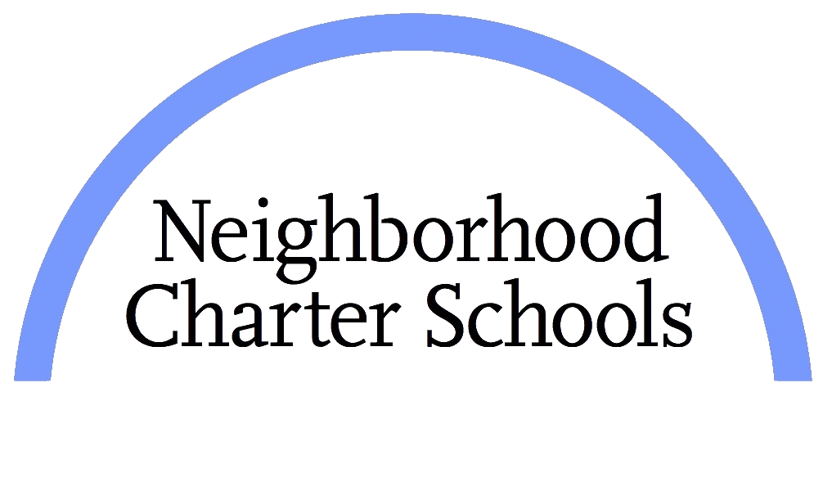

www.ncsharlem.org

Principal in Residence

Location: Harlem and Bronx, NY

Neighborhood Charter School: Harlem is one of the highest performing charter schools in New York State. NCSH has an accomplished founding leadership team that has been in place since the inception of the school in 2012. NCSH is looking for a highly motivated, dedicated, and skilled professional to lead new campus in the Bronx (Neighborhood Charter School: Bronx, which has already been approved by the New York State Education Department) as Principal for the 2019-2020 academic school year. To prepare for the role, and learn the Neighborhood Charter School (NCS) way, the idea candidate will join our leadership team in the fall as our Principal in Residence. Experience and demonstrated success in school leadership, in a high needs community with strong knowledge of curriculum and an unyielding belief that all children will succeed are all prerequisites for this position.

Mission of the School

Our mission is to provide the children of Harlem with new educational opportunities through a rigorous, comprehensive K-8 program that cultivates the intellectual, social and emotional development of each child. Our students, who will include high-functioning children with autism spectrum disorders, will become independent learners and critical thinkers, will acquire the academic skills that they need to succeed in college preparatory high schools and will exhibit the social and emotional skills that will allow them to reach their full potential.

Responsibilities of the Principal in Residence
- Assist the Principal in all aspects of effectively running the school
- Spend at least 90% of the school day learning with our principal, supervising staff members and providing actionable feedback which results in professional growth of teaching staff and improves Scholars achievement
- Meet very high targets which are set by the Board of Trustees and Executive Director
- Design New York State Learning Standard aligned curriculum across all subject areas which includes rigorous assessments and performance tasks aligned to the Common Core Learning Standards
- Design and deliver professional development sessions which result in academic growth among scholars
- Build relationships with families and be available 24 hours per day should there be a need
- Supervise after school and weekend programs as assigned by the Principal

Qualifications
- Extensive knowledge of scholars with IEPs
- Ability to lead, take charge of a situation and support others
- Ability to design individual growth skills for all employees
- Ability to “connect” with staff, scholars and families
- Experience working in an urban area with an unyielding belief in city schools
- Personal and professional dedication to public education and high expectations for scholars in New York City
- Excellent communication skills
- Impeccable organization skills
- Ability to work in a fast-paced, no excuses environment
- Self-starter and motivated to “think outside of the box”
- Ability to work long hours, which includes early arrival and late departure
- Have high expectations for self and other staff members
- Ability to “connect” with staff, families, community and scholars
- Represent the Principal and school in the community
- Ability to address large crowds of people with superior speaking abilities
- Bilingual preferred but not a requirement

Compensation

NCSH offers an extremely competitive salary and benefits package

To Apply

E-mail cover letter and resume to Ms. Alison Rosnick, Director of Talent arosnick@ncsharlem.org

Please do not apply if you do not have prior education leadership experience.

Please type “Principal in Residence” in the subject line of your e-mail.

Neighborhood Charter School: Harlem is an equal opportunity employer

